**Practical 8**

**(PART – A)**

|  |  |
| --- | --- |
| Roll No. A016 | Name: Varun Khadayate |
| Program: B-Tech (CSBS) | Division: Sem-III |
| Batch: 1 | Date of Experiment: 15-09-2020 |
| Date of Submission: 15-09-2020 | Grade: |

***Aim: To develop a turing machine.***

**Outcome:** After successfully competing of this practical, students will be able to learn:

* What is PDA?
* How it works?
* Converting NPDA to context free grammar

**A.1 Reading**

Read Page 59 to 74 of lab manual.

**A.2 Tasks**

1. Develop a PDA for the language L = {anbn} for n > 0 using JFLAP tool.
2. Convert the above PDA to context free grammar using the JFLAP tool.

**PART B**

(PART B: TO BE COMPLETED BY STUDENTS)

**(Students must submit the soft copy as per following segments within two hours of the practical. The soft copy must be uploaded on the Portal or emailed to the concerned lab in charge faculties at the end of the practical in case the there is no portal access available)**

**B.1 Output:**

1. Write a procedure to generate the PDA and NPDA using JFLAP tool.

**PDA**

* Open JFLAP tool
* Click on Pushdown Automaton option from the menu
* Add four states to the screen, setting the initial state to be q0 and the final state to be q3
* Set the initial and final states
* add a transition between the states q0 and q1
* Notice that there are three inputs instead of one.
* The value in the first box represents the input to be processed, the value in the second box represents the current value at the top of the stack, and the final value represents the new value to be pushed onto the top of the stack, after popping the value at the top of the stack off. There is no limit to the size of the values in any of these boxes.

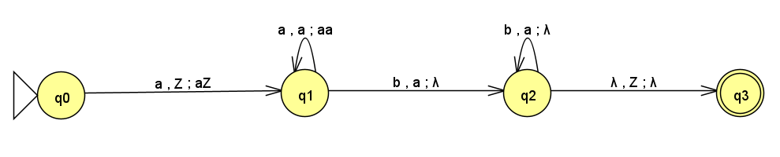

**NPDA**

* Open JFLAP tool
* Click on Pushdown Automaton option from the menu
* Add four states to the screen, setting the initial state to be q0 and the final state to be q3
* Set the initial and final states
* add a transition between the states q0 and q5
* Notice that there are three inputs instead of one.
* The value in the first box represents the input to be processed, the value in the second box represents the current value at the top of the stack, and the final value represents the new value to be pushed onto the top of the stack, after popping the value at the top of the stack off. There is no limit to the size of the values in any of these boxes.

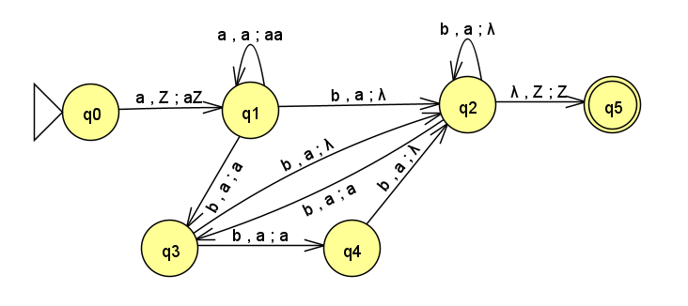

2. Write a procedure to convert PDA to unrestricted grammar using the JFLAP tool.

* Hover to the convert option.
* Click on convert to unrestricted grammar.
* Then click on show all.

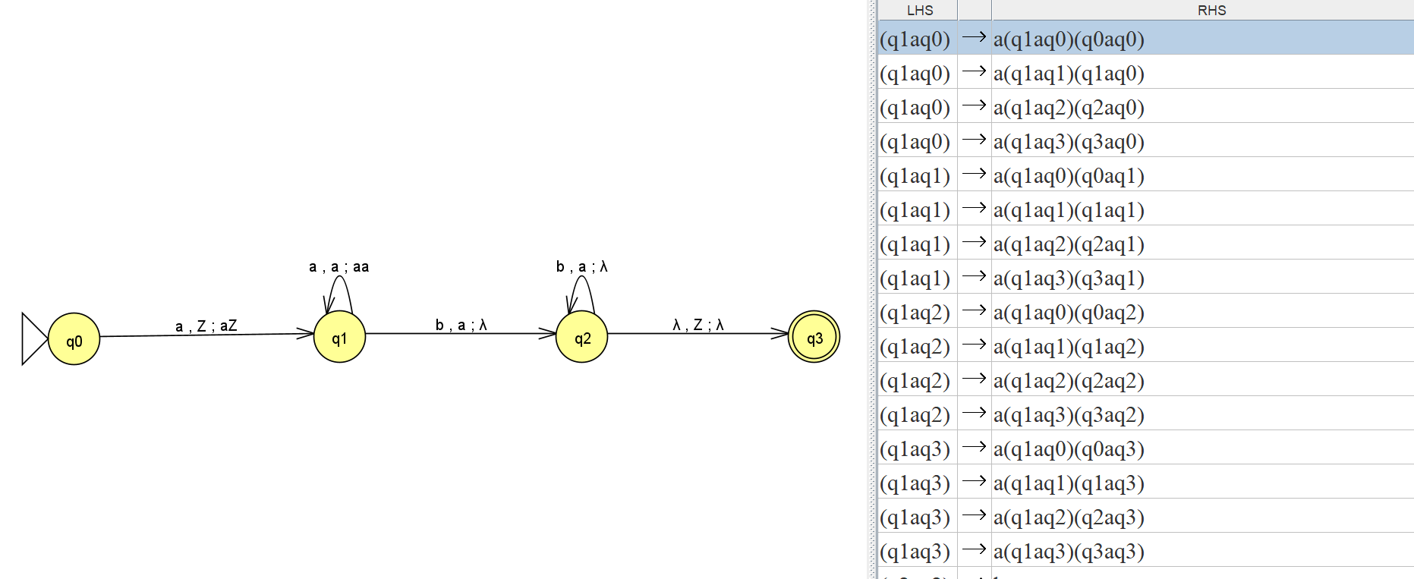

**B.2 Observations/Learning**

*(Students are supposed to write the logic of constructed DFA and generated regular expression)*

We were able to design a PDA and NPDA for the given language and successfully convert the PDA to unrestricted grammar.

**B.3 Conclusion:**

*(Students must write the conclusion as per the attainment of individual outcomes and learning/observation)*

The conclusion was derived from the experiment was that both the PDA and NPDA accepts the strings that contain equal number of a’s and b’s.

***B.4 Curiosity Question***

***Can you generate a general formula to find total number of states when positions of particular input is fixed from left hand side? Explain***